Modern Method Software Engineering
Home work 3
Shanbo Li | 840810-A478 | shanboli@Gmail.com | 0704646157
Sike Huang | 850414-A394 | sike.huang@gmail.com | 0762320173

2007-9-29

Question 1: Draw class diagram corresponding to this sequence diagram

Answer：
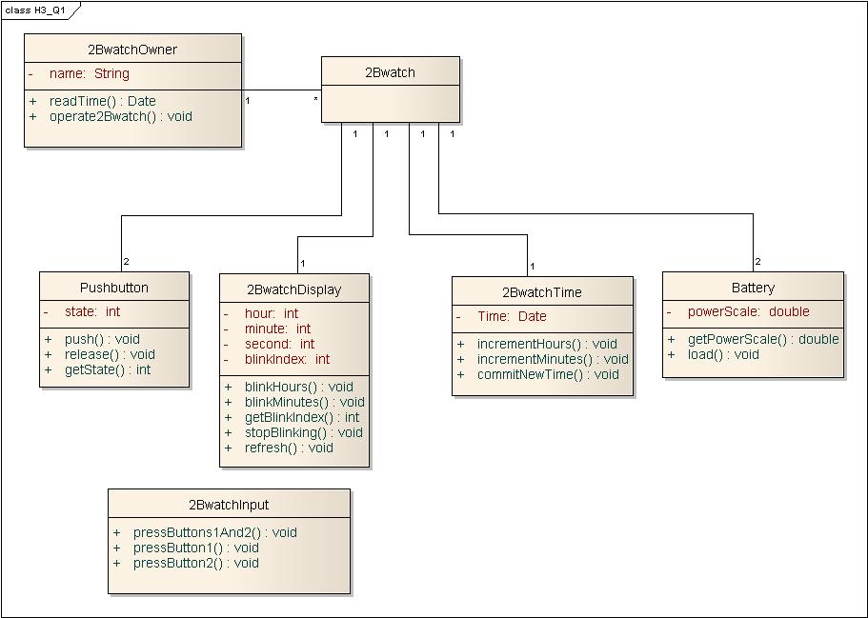
Figure 1 2Bwatch class diagram

The sequence diagram is not a good sequence diagram, for it is not clear which class is boundary and which is control. As this question require draw a class diagram corresponding to this sequence diagram. We draw the class diagram Figure 1. And we also draw a class named 2BwatchInput as a control like class(if it is a real control class, it should be at the 3rd column of sequence diagram).

Question 3: Draw state-chart describing the behavior of the AnnounceTourna- mentControl object based on the sequence diagrams of figure 5-26 through 5-28. (Bonus point 01).

Answer:

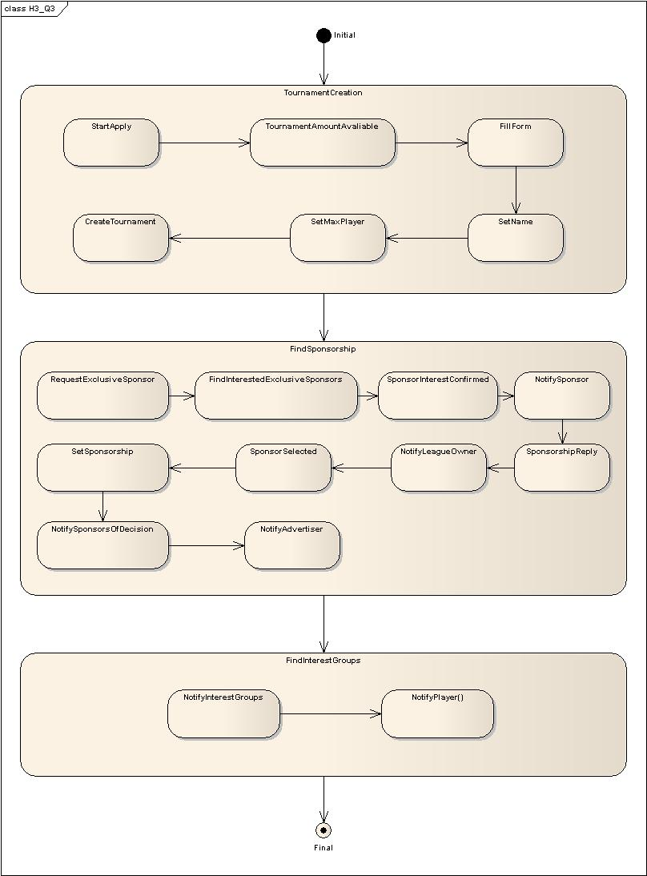
We rearranged some state, for the first sequence of Figure 5-28 (from notifySponsorsOfDecision to notifyAdvertiser ) should be in the FindSponserShip substate.

